Vernacular Names: Cheesefruit, Indian Mulberry, Noni (Hawaii) | Scientific Name: Morinda citrifolia L.
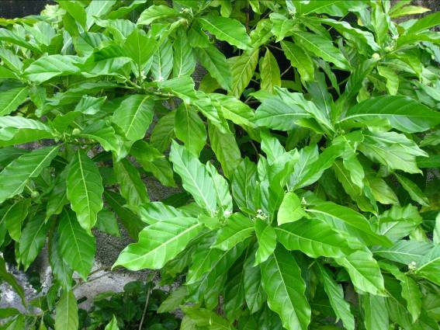 | 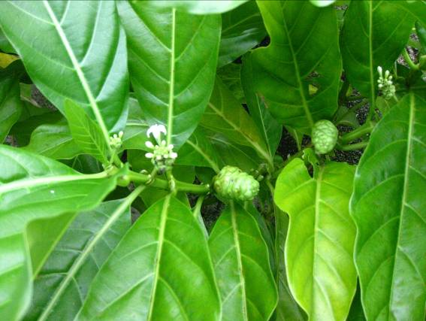
Full tree form | Details of flower & fruit
Native or Introduced: Native

Description: Under-storey small tree. Large pointed shiny green leaves, deeply-veined. Clusters of white flowers, each with a long corolla. Fruit a large cluster, mulberry-like in appearance, ripening from hard green to soft white with a cheesy “fermented” smell. Small tree form, mulberry-like fruit, and large pointed leaves make this tree distinctive.

Habitat: Grows beneath other trees, at least initially, even in the intense shade of un-managed coconut thicket, struggling and twisting its way towards any gap in the canopy. Widespread in almost all habitat types on Chagos, and salt-tolerant to a degree.

Human uses: Edible fruit. Medicinal uses (analgesic) from fruit, leaves and roots. Bark produces a dye.

Significance: Fast –growing small tree. Rapidly produces shade for others.

Propagation: Fruit once ripe (white and sticky). Seedlings usually abundant near a larger tree. Might grow from cuttings of 2nd year wood. Good nursery species since rapid growth.

